
ANALYISIS



PATIENT
CARE OUTCOMES

Project by
Seshwanth K.S

TREND ANALYSIS
LENGTH OF STAY

Departments with the Longest Average Length of Stay (LOS):
- Dermatology – ~11 days
- Orthopaedics – ~10 days
- Psychiatry – ~8 days
- Paediatrics – ~6 days

Departments with Moderate LOS (~4–6 days):
  - Anaesthesiology
  - Urology
  - Pulmonology
  - General Surgery
  - ENT
  - Nephrology
  - Oncology
  - Neurology
  - General Medicine

Departments with the Shortest LOS (<4 days):
  - Plastic and Reconstructive Surgery
  - Obstetrics and Gynaecology
  - Ophthalmology
  - Cardiology
  - Oral and Maxillofacial Surgery (Dental) – has the shortest LOS, nearly 0 days

Observations:
  - Dermatology stands out with the longest average stay.
  - Surgical and dental departments tend to have shorter stays.
  - Mental health and chronic care departments like Psychiatry and Paediatrics have
higher LOS, which is typical due to the nature of care required.

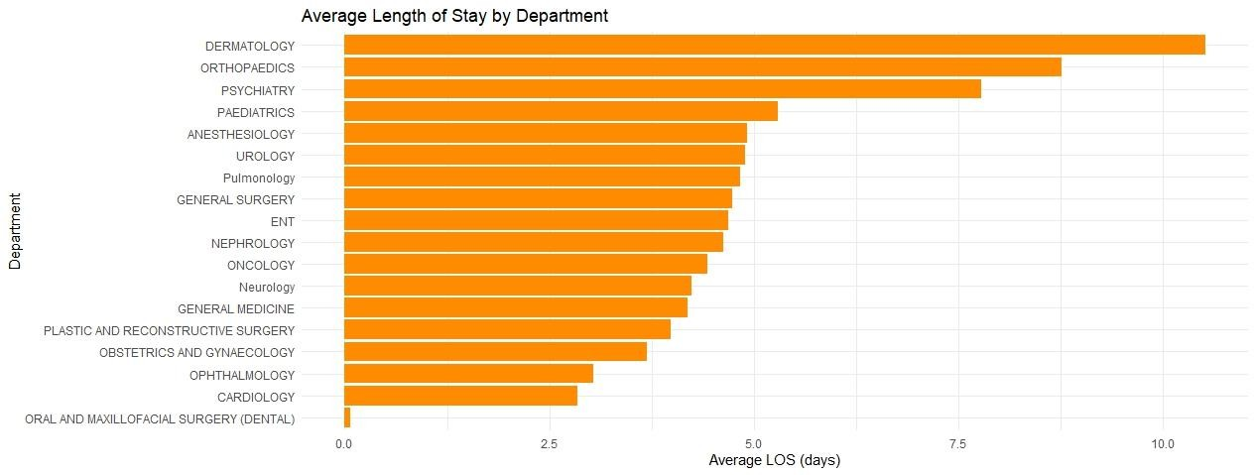

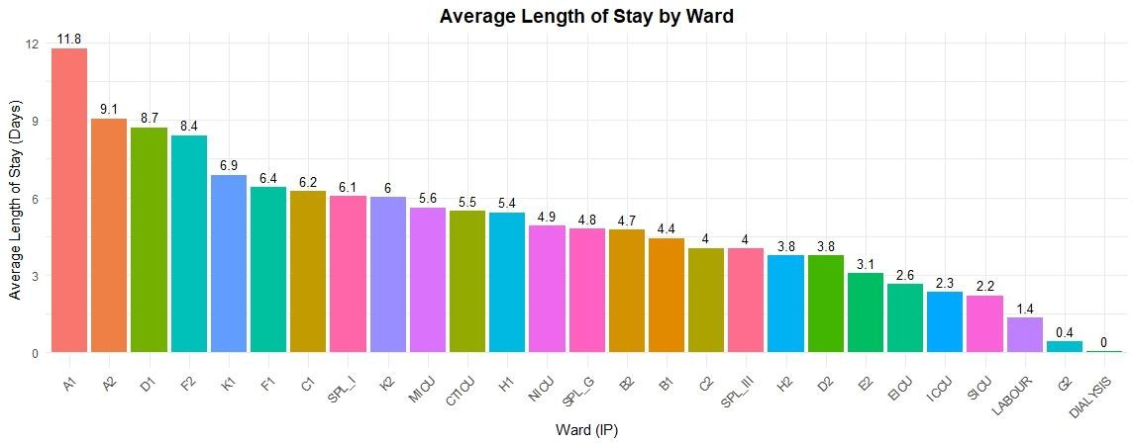


2022 - 2024

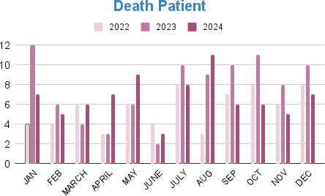

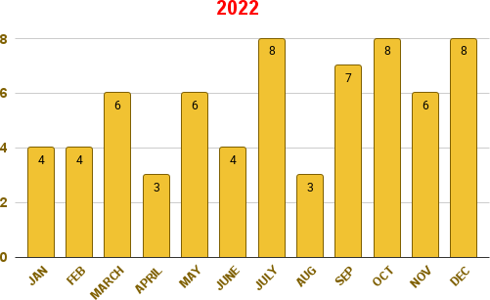

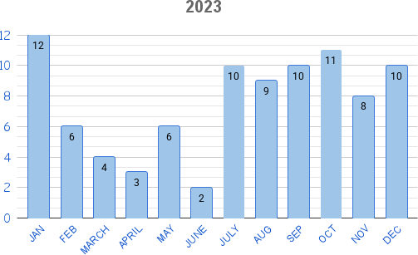

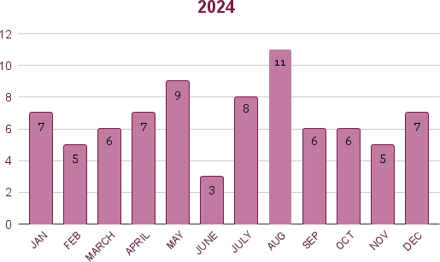

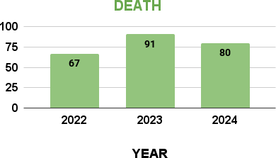

Death Patient Analysis (2022–2024)
Overall Trend :
  - Death counts fluctuate month to month, with noticeable peaks during January, July, August, and October.
  - 2024 shows a more consistent death rate compared to previous years.
  - 2022 had the highest single-month count (January – 12 deaths), while 2023 and 2024 show better control in early months.
Yearly Comparison :
  - 2022: High early-year deaths (Jan–May), moderate rest of year.
  - 2023: Even distribution throughout the year, peaking in August and September (~10 deaths each).
  - 2024: Moderate pattern, peaks in October (10 deaths) and July (8 deaths).
Seasonal Insights :
  - Winter (Jan–Feb): 2022 had extreme rise, other years moderate.
  - Mid-Year (Jun–Aug): Consistent increase across all years, possibly seasonal or infection- related.
  - Late-Year (Sep–Dec): Gradual stabilization, though October remains a repeated high month.
Key Observations :
  - January (2022) is a clear outlier with the maximum deaths.
  - July–October shows recurring peaks → could indicate annual seasonal impact.
  - The overall trend suggests improved mortality control in later years.

TR

